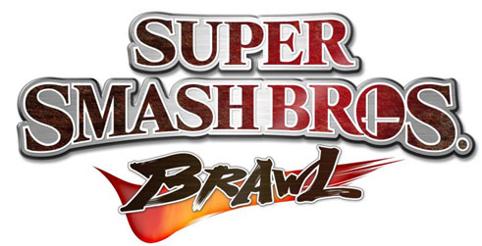

RULES

- 5 stock with a 5 minute timer
- Ties are settled with the standard sudden death of Brawl
- Meta Knight BANNED
- No wobbling (Ice Climbers Chain Grabs)
- No Custom Stages
- No Stages that Interrupted Gameplay
- No Stages that Move in the foreground (ie. Rainbow Cruise & Flatzone)
- No edge guarding longer than 5 game seconds
- Melee Item (ie. Baseball bat and Sword) will be set to very low
- Finals will be a 5 stock best of three with unlimited time. The loser gets to picked the next stage as long as the stage does not break the stage choice rule.

